1. Error on Appplication page   
   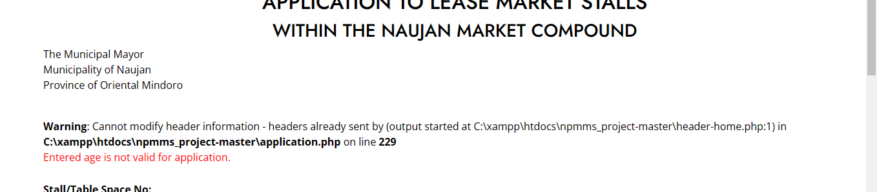
2. Same With This   
   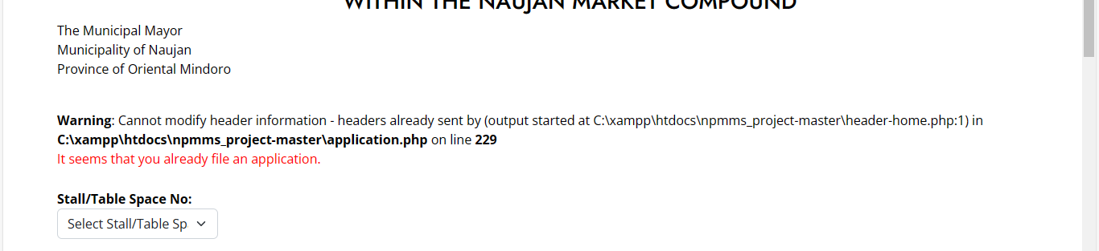
3. When clicking on the Alert at Verification It redirecting on 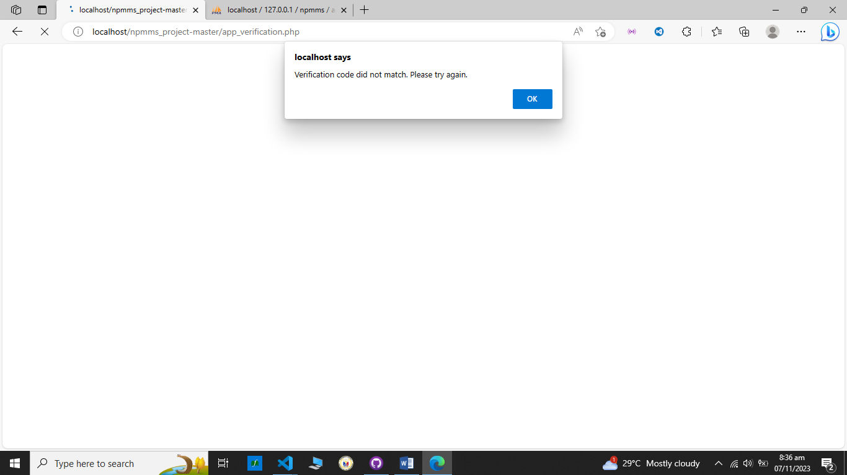
4. Note : one admin cannot deactivated so (so may matitirang isang account na di pede inactive let say for instance pano kapag yung may nag access ng admin account and he deactivated all account so d na sia accessible so to prevent that thing to happen it should be one admin cannot be deactivated)
5. Overlapping table Content 